SCHOOL OF COMPUTER SCIENCE AND ARTIFICIAL INTELLIGENCE |  |  |  |  | DEPARTMENT OF COMPUTER SCIENCE ENGINEERING
Program Name: B. Tech |  |  |  | Assignment Type: Lab |  |  | Academic Year:2025-2026
Course Coordinator Name |  |  |  | Venkataramana Veeramsetty
Instructor(s) Name |  |  |  | Dr. V. Venkataramana (Co-ordinator)  Dr. T. Sampath Kumar  Dr. Pramoda Patro  Dr. Brij Kishor Tiwari  Dr.J.Ravichander  Dr. Mohammand Ali Shaik  Dr. Anirodh Kumar  Mr. S.Naresh Kumar  Dr. RAJESH VELPULA  Mr. Kundhan Kumar  Ms. Ch.Rajitha  Mr. M Prakash  Mr. B.Raju  Intern 1 (Dharma teja)  Intern 2 (Sai Prasad)  Intern 3 (Sowmya)  NS_2 ( Mounika)
Course Code |  |  | 24CS002PC215 | Course Title |  | AI Assisted Coding
Year/Sem |  |  | II/I | Regulation |  | R24
Date and Day  of Assignment |  |  | Week7 - Monday | Time(s)
Duration |  |  | 2 Hours | Applicable to  Batches
AssignmentNumber:14.1(Present assignment number)/24(Total number of assignments)
 | Q.No. | Question |  |  |  |  |  | Expected Time  to complete
 | 1 | Lab 14: Web Design Application – AI-Assisted HTML/CSS/JS Generation  Lab Objectives  - Design functional, visually appealing web applications using HTML, CSS, and JavaScript with AI assistance.  - Apply responsive, accessible, and interactive design principles.  - Create practical UI components for real-world web applications.  - Use AI to optimize layout, UX, and performance.  Task 1 – Portfolio Website Design  You are building a personal portfolio website to showcase your work.  Requirements:  - Create sections for About Me, Projects, and Contact.  - Use AI to:  - Suggest color palettes and typography.  - Create a responsive layout with Grid/Flexbox.  - Add smooth scrolling navigation.  Prompt:  Generate a responsive personal portfolio single-page website using HTML, CSS (Grid/Flexbox), and JavaScript for smooth scrolling navigation. Include sections: About Me, Projects (3 sample projects with images/placeholders), and Contact (email link + contact form). Suggest a 3-color palette and a combination of a serif heading font and a sans-serif body font. Use CSS variables for theme, responsive breakpoints, and accessible semantic markup. Add a mobile-first layout and keyboard-accessible navigation.  Code:  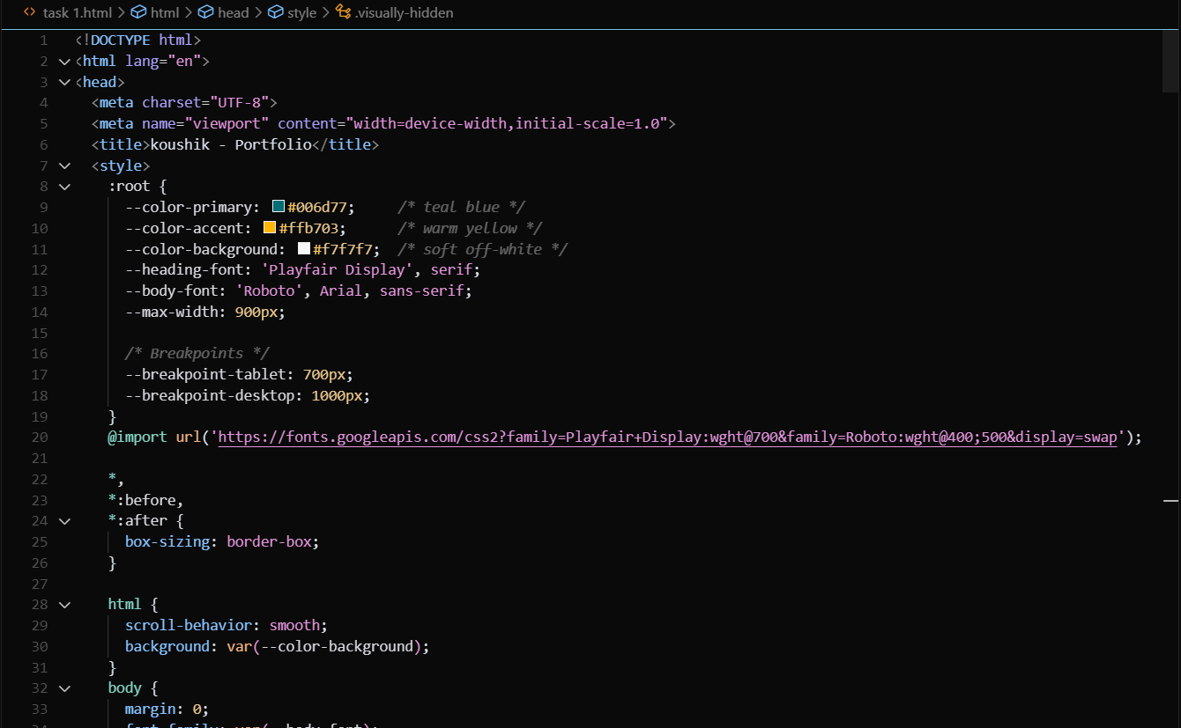  Output:  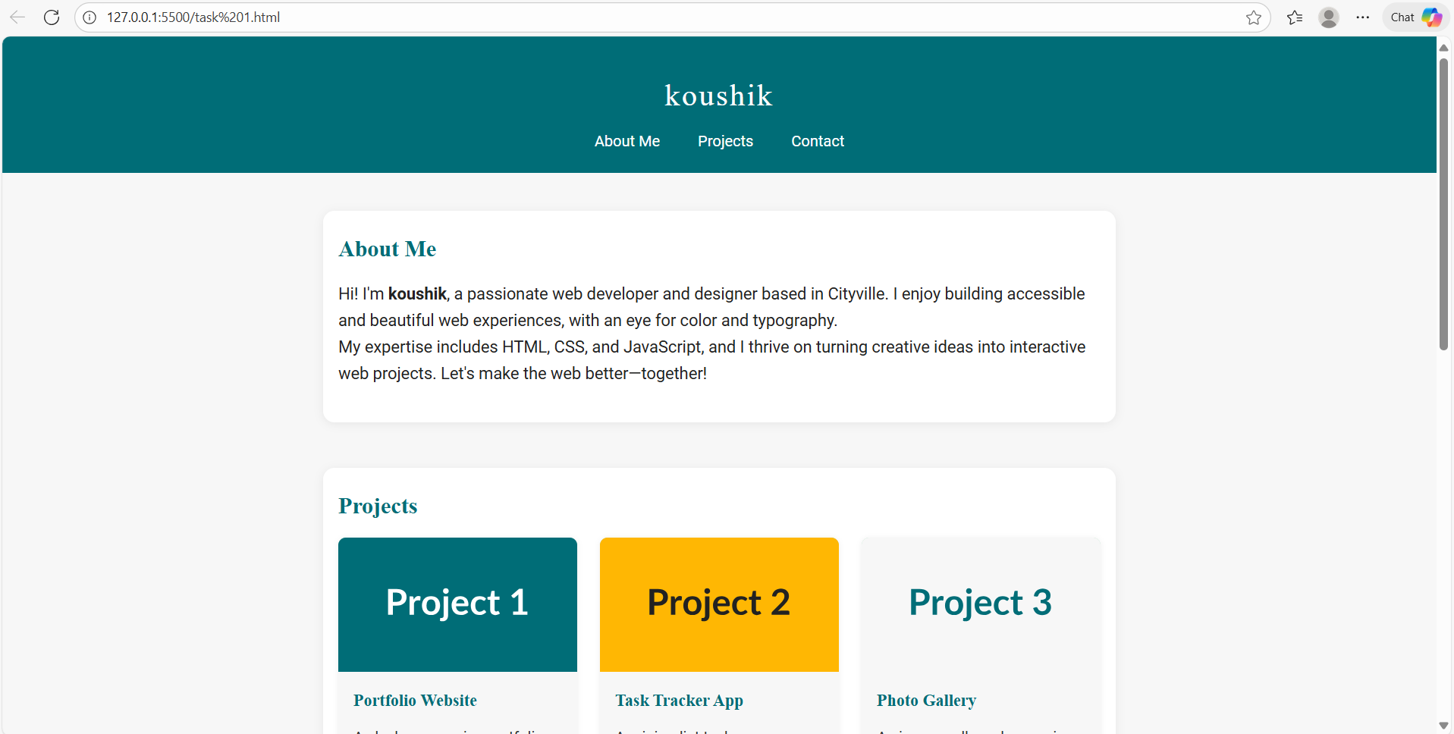  Task 2 – Online Store Product Page  Design a product display page for an online store.  Requirements:  - Display product image, title, price, and "Add to Cart" button.  - Use AI to:  - Style with BEM methodology.  - Make layout responsive.  - Add hover effects and "Add to Cart" alert.  Prompt:  Create a responsive product card UI for an online store using BEM naming. The card should show product image, title, price, and an 'Add to Cart' button. Implement hover effects, responsive behavior for mobile/desktop, and a JavaScript handler that shows a non-blocking alert (toast) when 'Add to Cart' is clicked. Follow accessible button markup and aria-live region for toast messages.  Code:  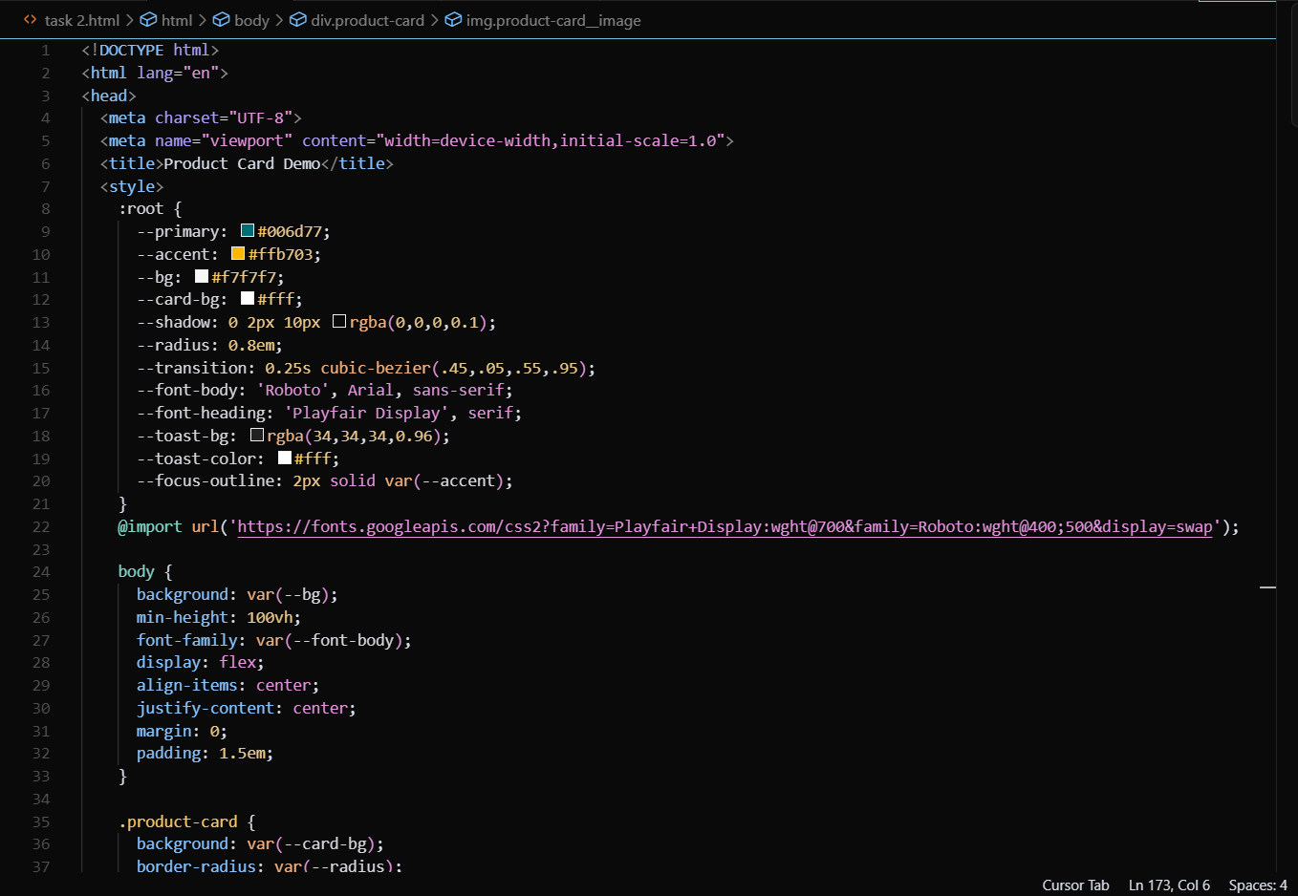  Output:  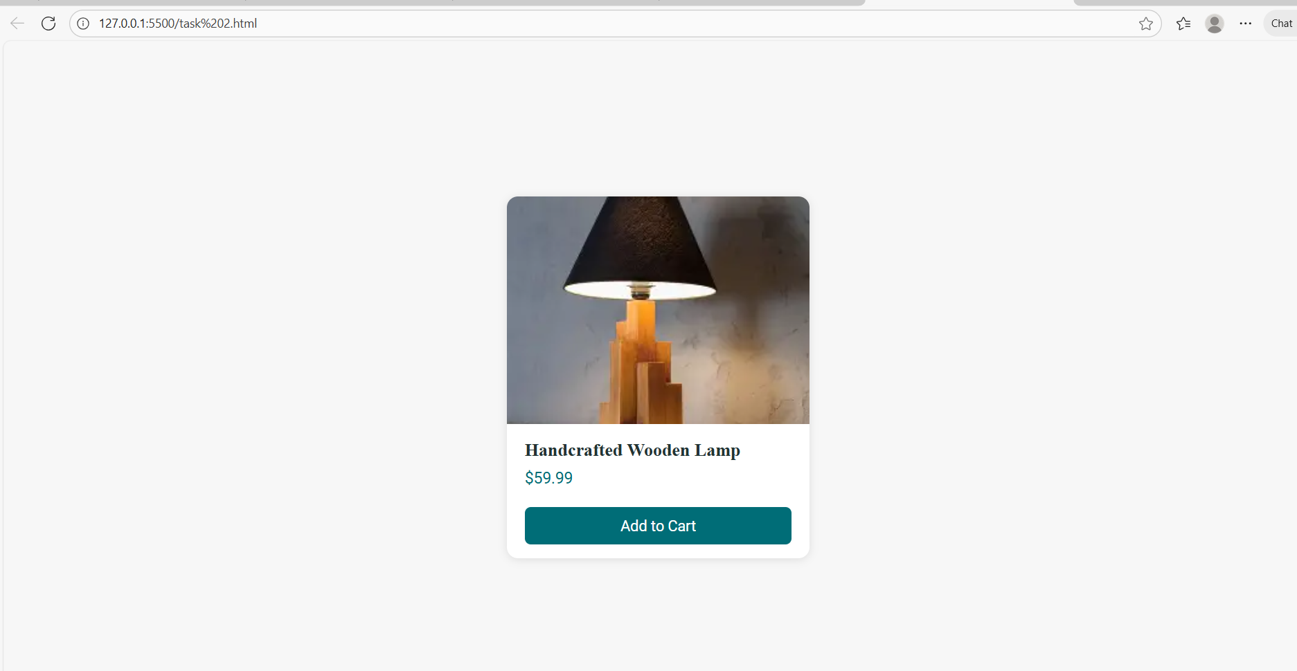  Task 3 – Event Registration Form  Build an event registration form for a conference.  Requirements:  - Collect name, email, phone number, and session selection.  - Use AI to:  - Add form validation with JavaScript.  - Make the form accessible with labels and ARIA.  - Style with a professional look.  Prompt:  Build an accessible event registration form to collect Name, Email, Phone, and Session Selection (radio or select). Add client-side validation: name required, email pattern, phone numeric/length check, session required. Use labels, aria attributes, and show inline error messages. Style with a professional look and responsive layout. Provide JS unit tests (3 cases) for the validation functions.  Code:  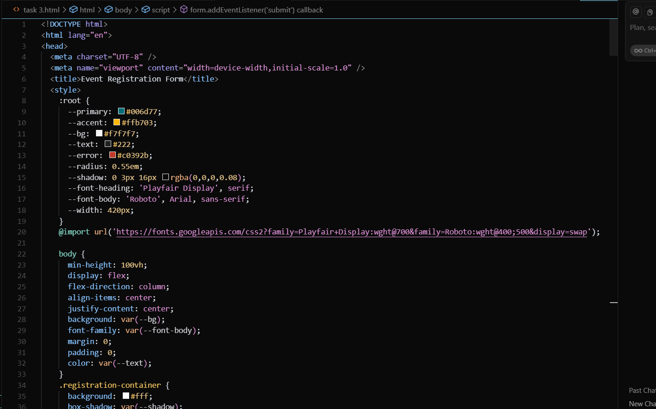  Output:  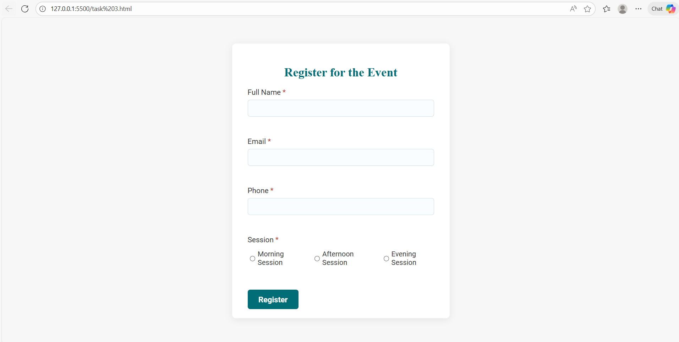  Task Description #4 (Data – Fetch API & Render List with Loading/Error States)  - Task: Fetch JSON from an API and render items to the DOM with loading and error UI.  - Instructions:  - Ask AI to write fetch() logic, create DOM nodes safely, and add skeleton/loading text.  Prompt:  Write JavaScript fetch() logic to GET JSON from a sample API endpoint (https://jsonplaceholder.typicode.com/posts?_limit=6). Render items as safe DOM nodes with a skeleton loading UI and an error state. Use try/catch, abortable fetch with timeout, sanitize text (textContent), and show accessible loading and error messages. Provide test cases simulating success, network error, and slow response (use mocks or describe manual test steps).  Code:  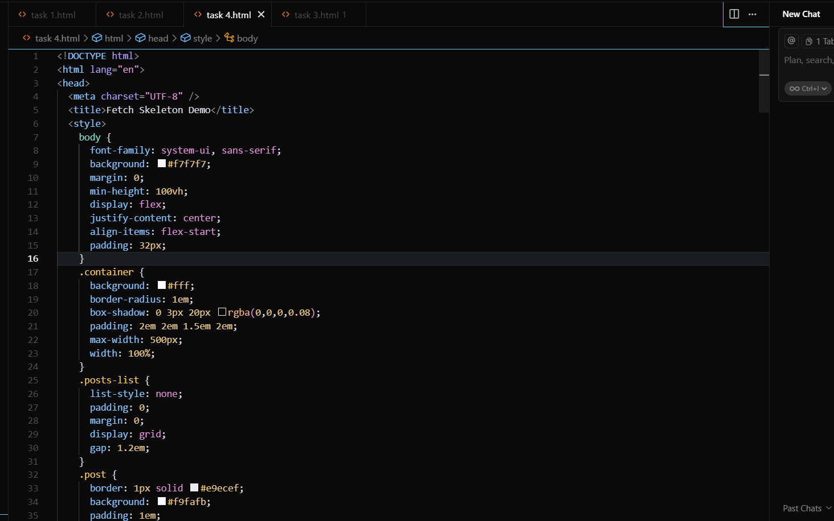  Output:  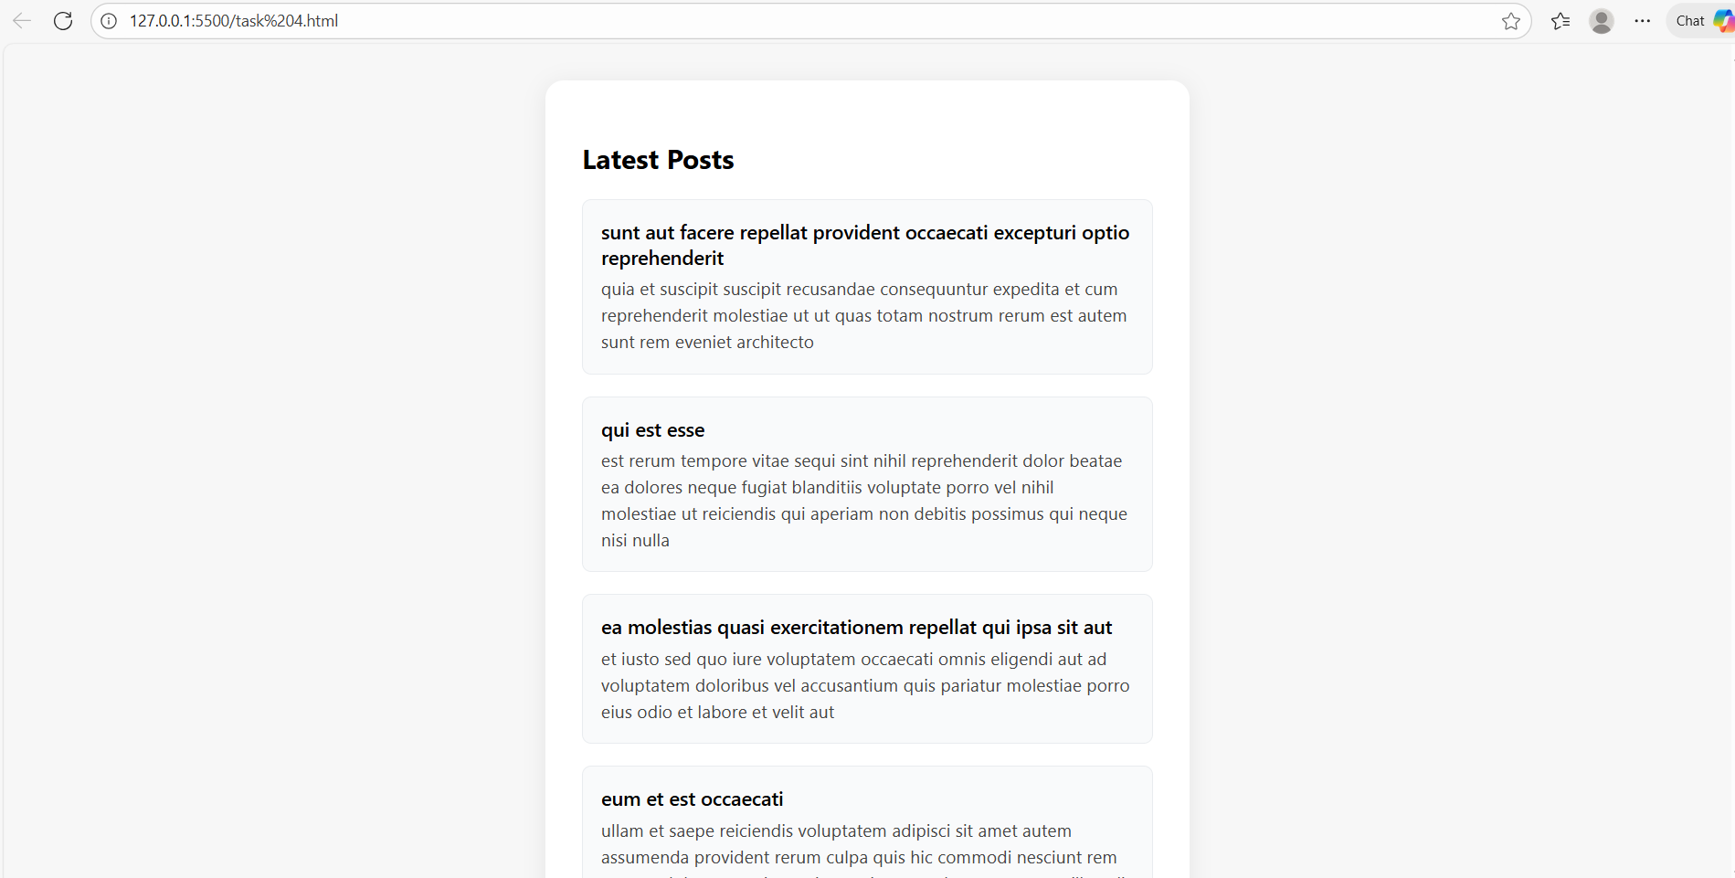  ✅ Deliverables (For All Tasks)  - AI-generated prompts for code and test case generation.  - At least 3 assert test cases for each task.  - AI-generated initial code and execution screenshots.  - Analysis of whether code passes all tests.  - Improved final version with inline comments and explanation.  - Compiled report (Word/PDF) with prompts, test cases, assertions, code, and output. |  |  |  |  |  | Week7 - Monday

